| **데이터베이스**  **요구사항 분석서** |
| --- |

| **과제명 :** |  |
| --- | --- |

| **2018. 00. 00** |
| --- |

| **팀명** |
| --- |

**Ⅰ. 요구사항 정의서**

**예시)**

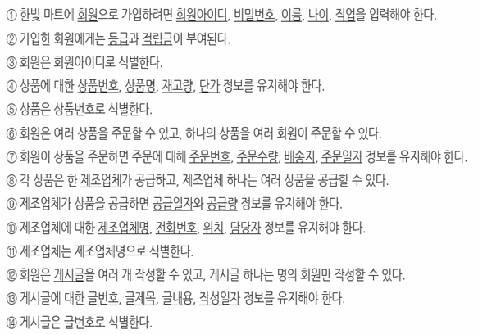

**2. 객체 정의서**

| **객체 명** | **속성 명** |
| --- | --- |
|  |  |
|  |  |
|  |  |
|  |  |
|  |  |

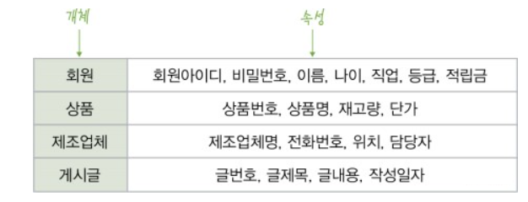

**3. E-R Diagram**